CUSTOMER TABLE

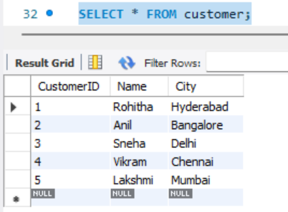

ORDERSS TABLE

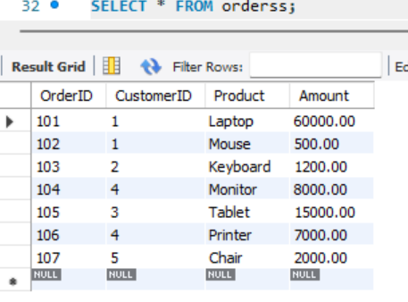

JOINS

INNER JOIN

LEFT JOIN

RIGHT JOIN

FULL JOIN

